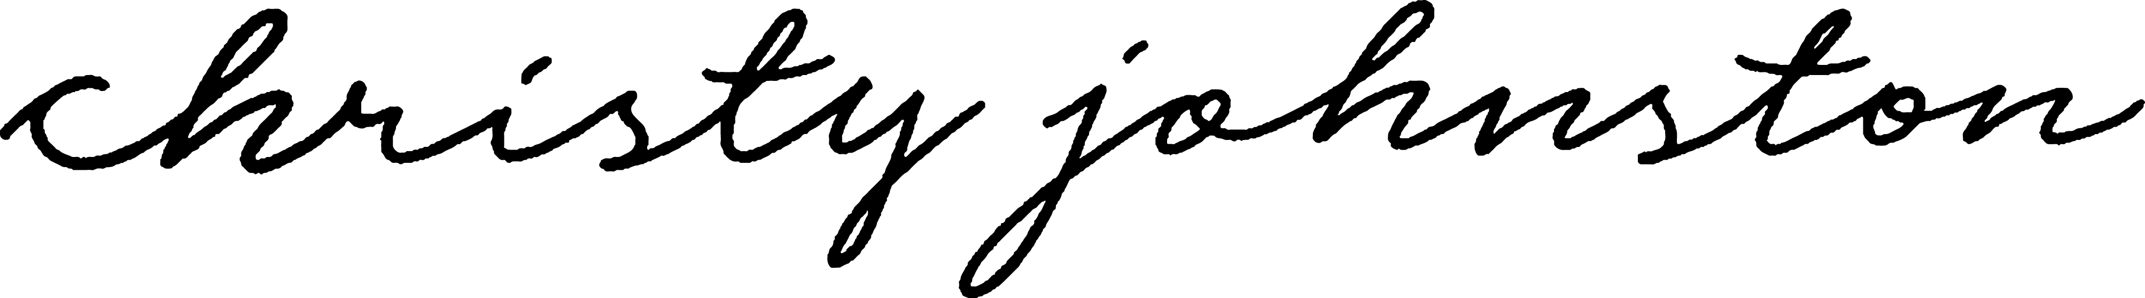

first look shot list

This shot list is a space where you can let me know if there is a specific moment you don’t want me to miss! I do my absolute best to capture significant moments, but please let me know if I should be aware of anything else! Just type it into the category in which it falls below! Then fill out your family shot list with names. Easy!

Getting Ready
- Candid Shots with bridal party + family
- Detail Shots (if you could bring your invitation suite and any other details – that would be great!)

Before the Ceremony

(Please fill in names or delete the shots you don’t need. It is good to note that the more specific family photos you request – the less time you will have with your guests, for couple photos, etc. It is helpful to group people together rather than individual shots. However, it is completely up to you! List below and we will make it happen!)
- Bride with her entire immediate family
- Bride with both parents
- Bride with her father
- Bride with her mother
- Bride with siblings
- Bride with each individual sibling

- Groom with his entire immediate family
- Groom with both parents
- Groom with his mother
- Groom with his father
- Groom with siblings
- Groom with each individual sibling

- Bride + Groom with Bride’s family
- Bride + Groom with Bride’s parents
- Bride + Groom with both immediate families
- Bride + Groom with all siblings
- Bride + Groom with Groom’s family
- Bride + Groom with Groom’s parents

- Bride + Groom with bridesmaids
- Bride + Groom with groomsmen
- Bride + Groom with all
- [Serious and/or funny]

- Bride and Groom with family available (please list below all family who will be there before the ceremony, I will check off “after the ceremony” if you list them here)

- Bride + Groom couple photos

The Ceremony
- Shots of all moments/reactions/happenings of the ceremony
After the Ceremony (please fill in names – in this section, please add in any family photos you would like [aunts, uncles, cousins, flower girls, etc]. List the groupings with names)
- Bride + groom with bride’s whole + extended family
- Bride + groom with groom’s whole + extended family
- Bride + groom with groom’s grandparents
- Bride + groom with bride’s grandparents
Dismiss Everyone
- Bride and groom together

The Reception

